**Phan Huy Khánh – 22IT.B107 – Lab 4 – Ex 7-1**

1. Run <http://localhost/ex_starts/ch07_ex1/>

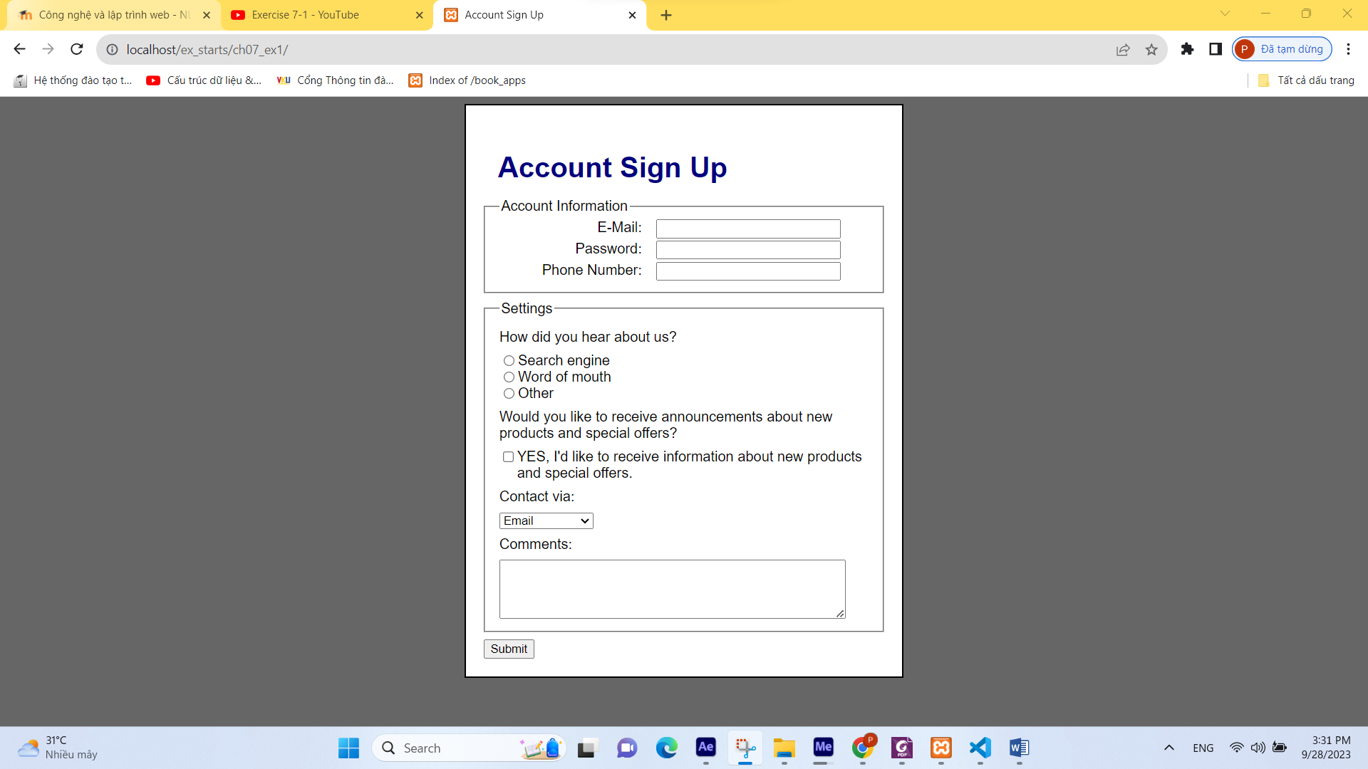

1. Enter some data, including a valid email address, and click submit button. This should only display the data that you entered for the email address.

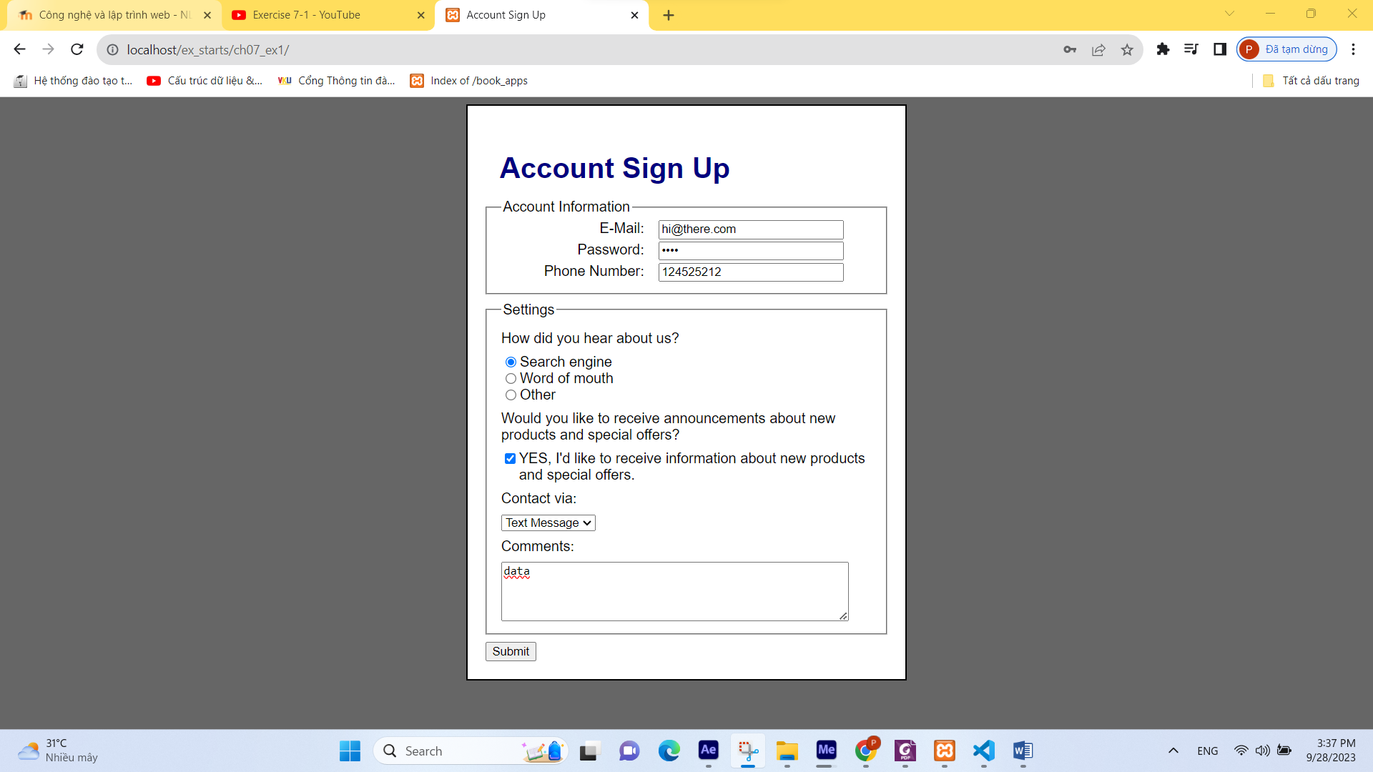

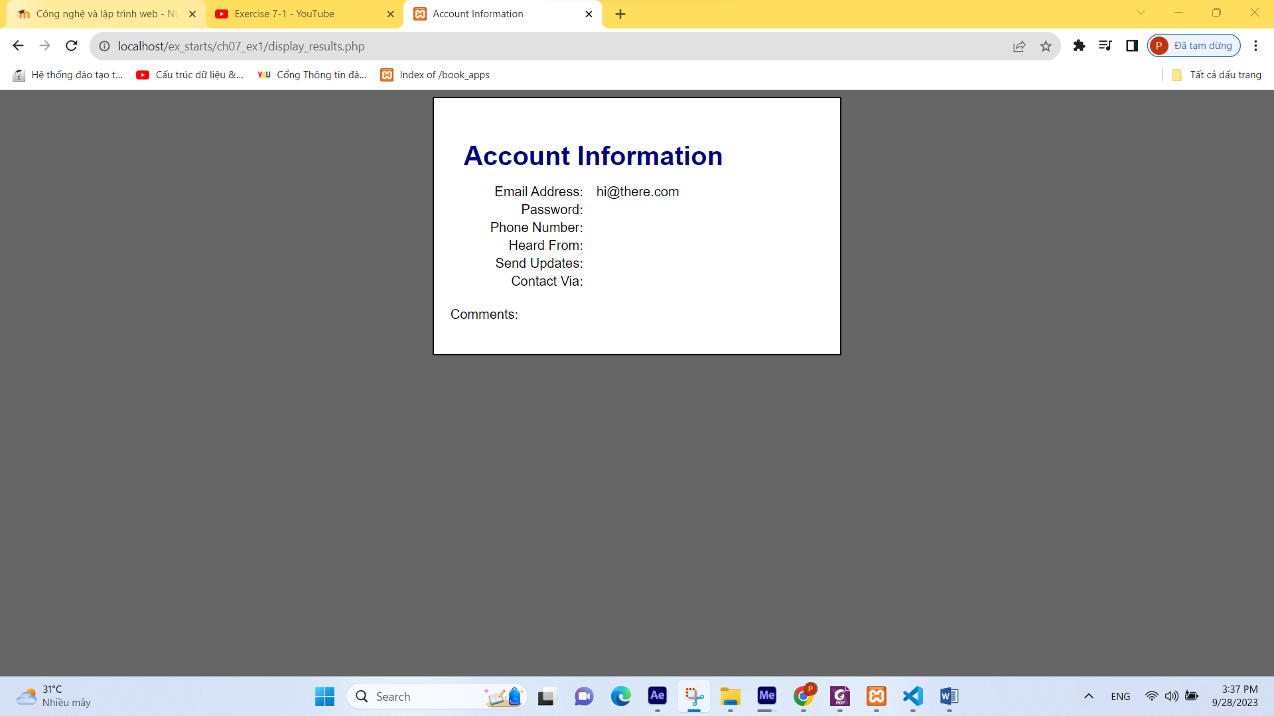

1. Open index.php and review the code.

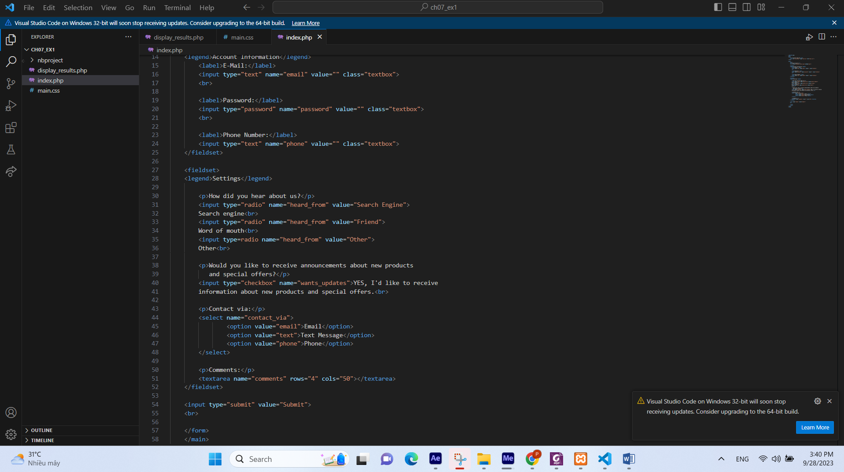

1. Open the display_results.php and review the code. Note that most of the code that gets data from the controls is missing.

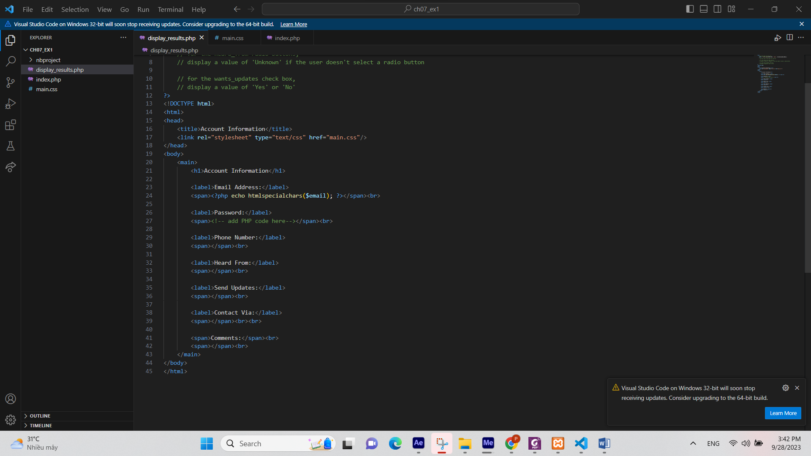

1. Add the code that gets the data from the controls on the first page. Then, add the code that displays this data.

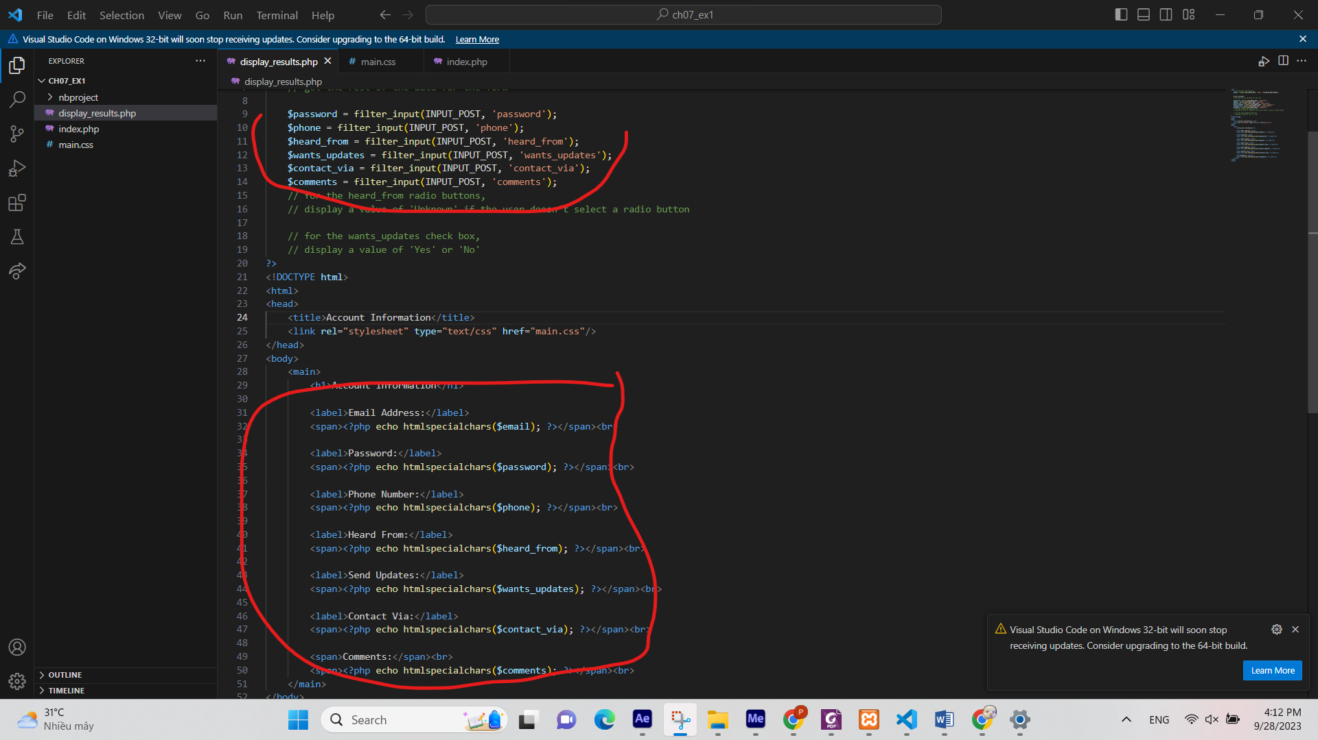

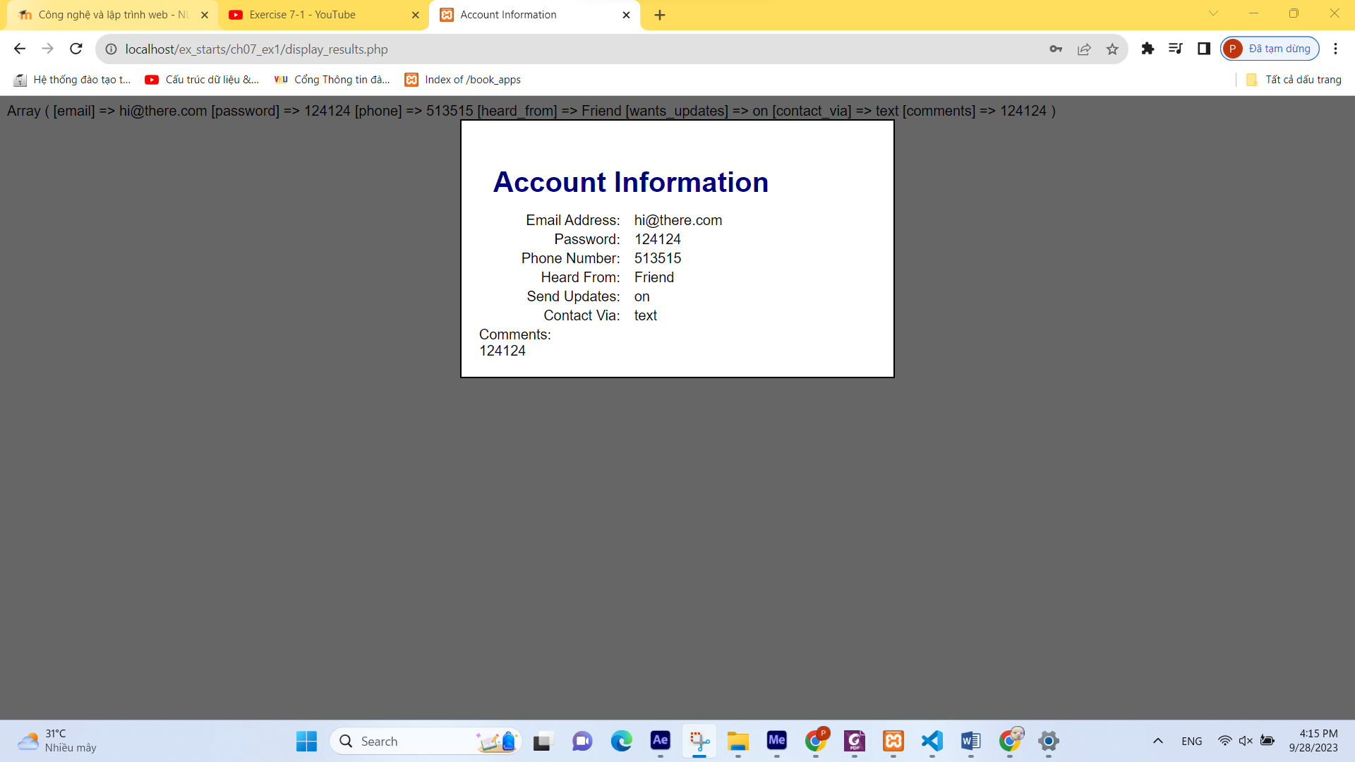

1. For the radio button, display the value of “Unknown” if the user doesn’t select a radio button.

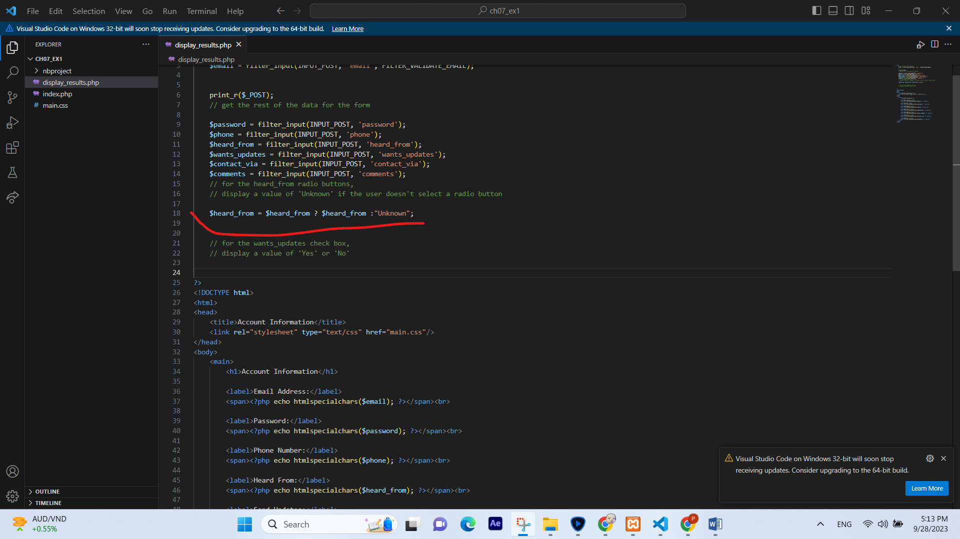

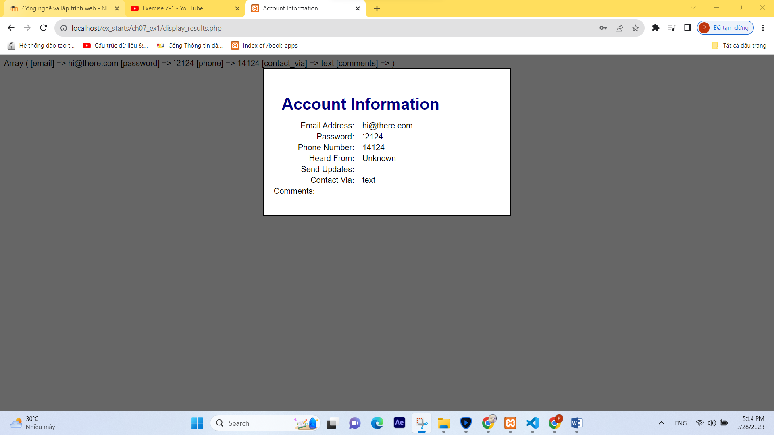

1. For the check box, display a value of “Yes” or “No” depending on whether the user has selected the check box.

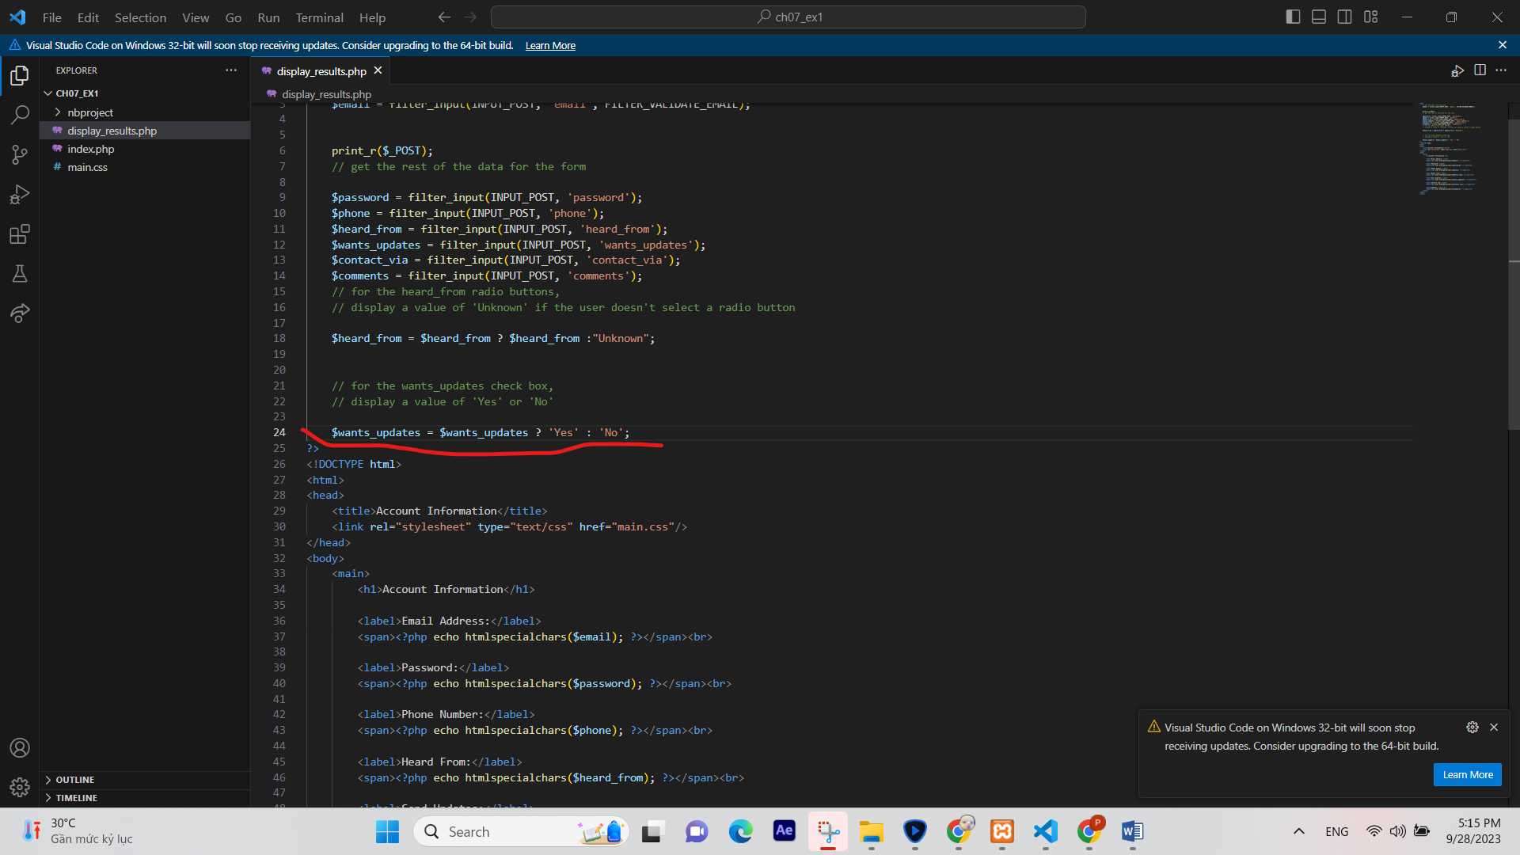

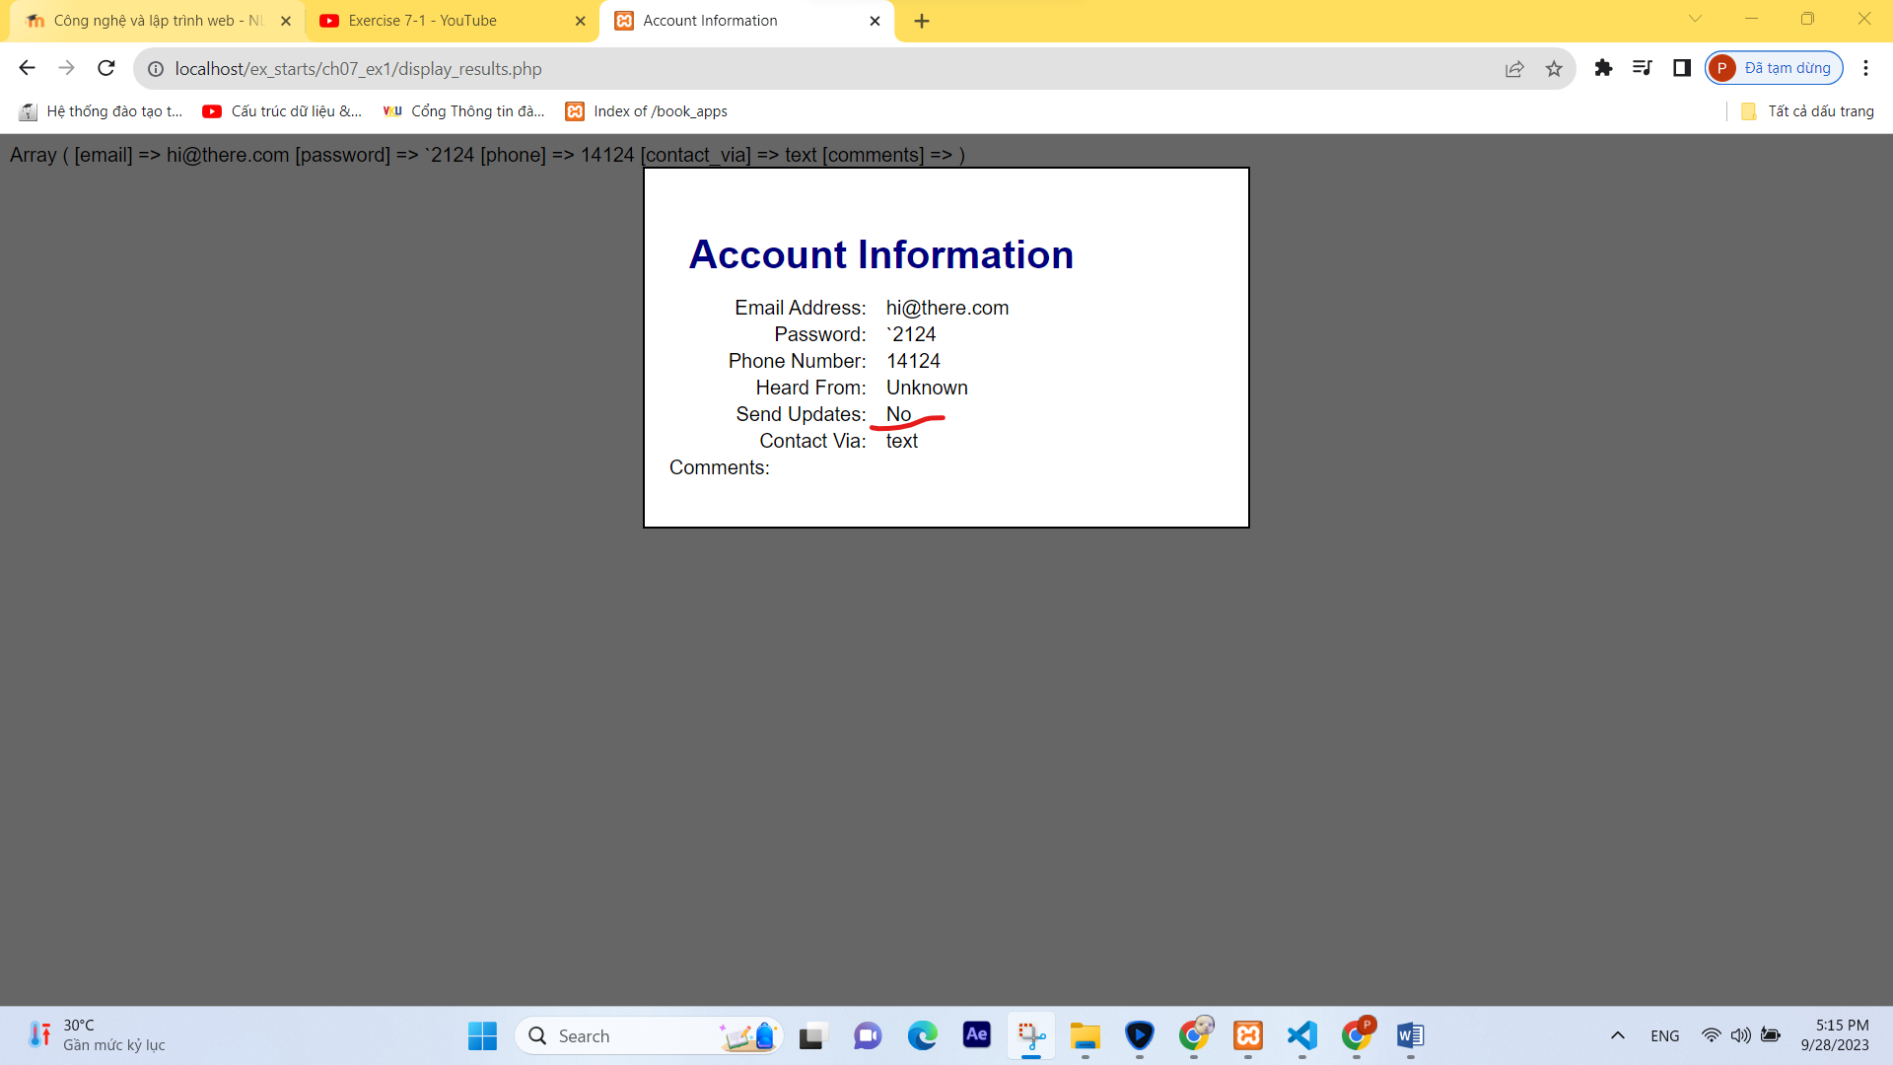

1. For all fields, make sure to convert special characters into HTML entities before displaying that data on the second page.

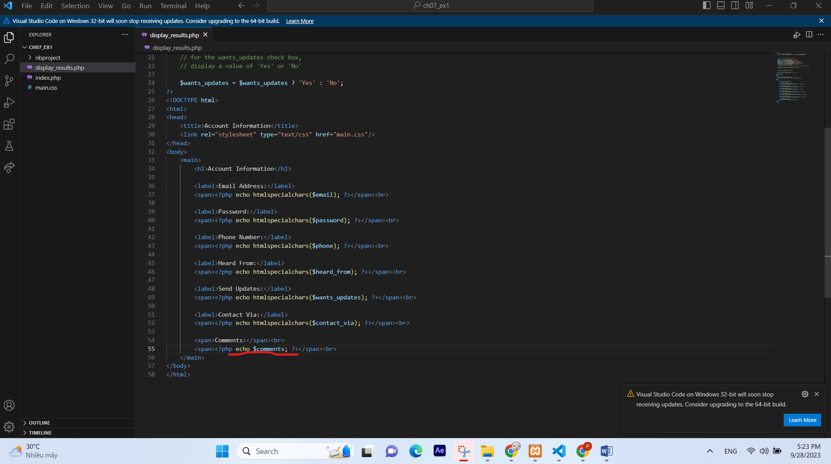

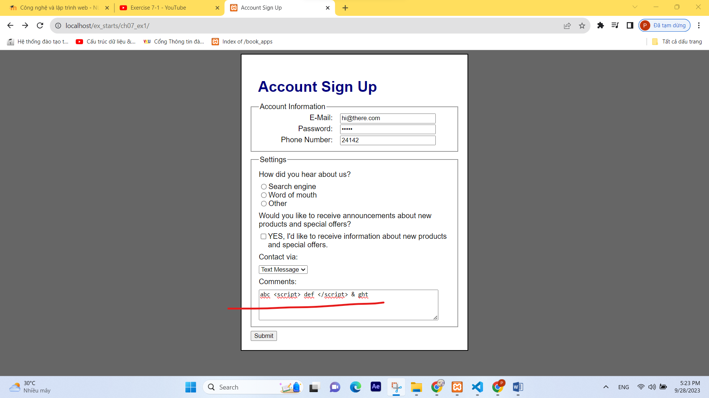

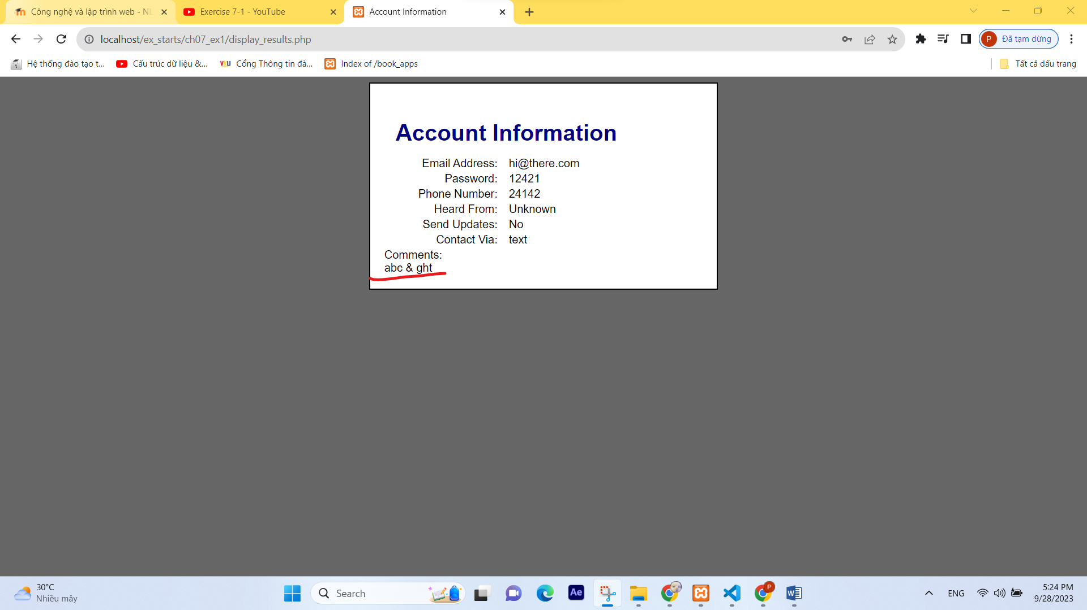

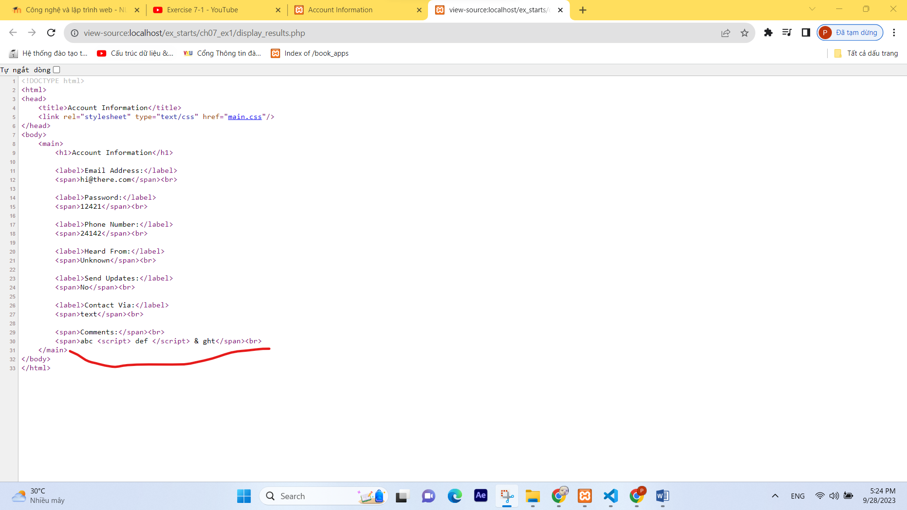

1. For the comment field, make sure to convert new line characters to <br> tags so the web page can display new line characters correctly.

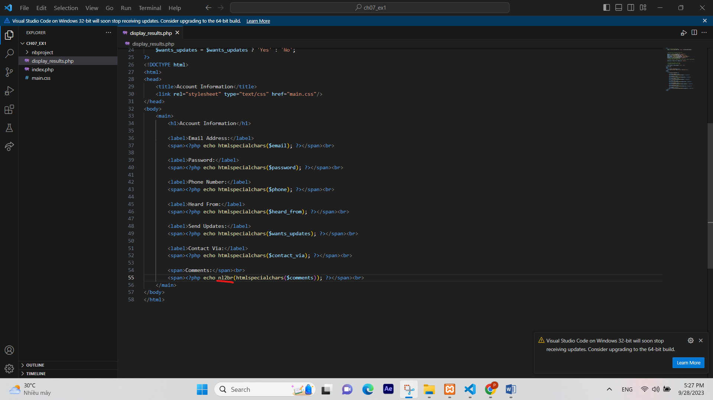

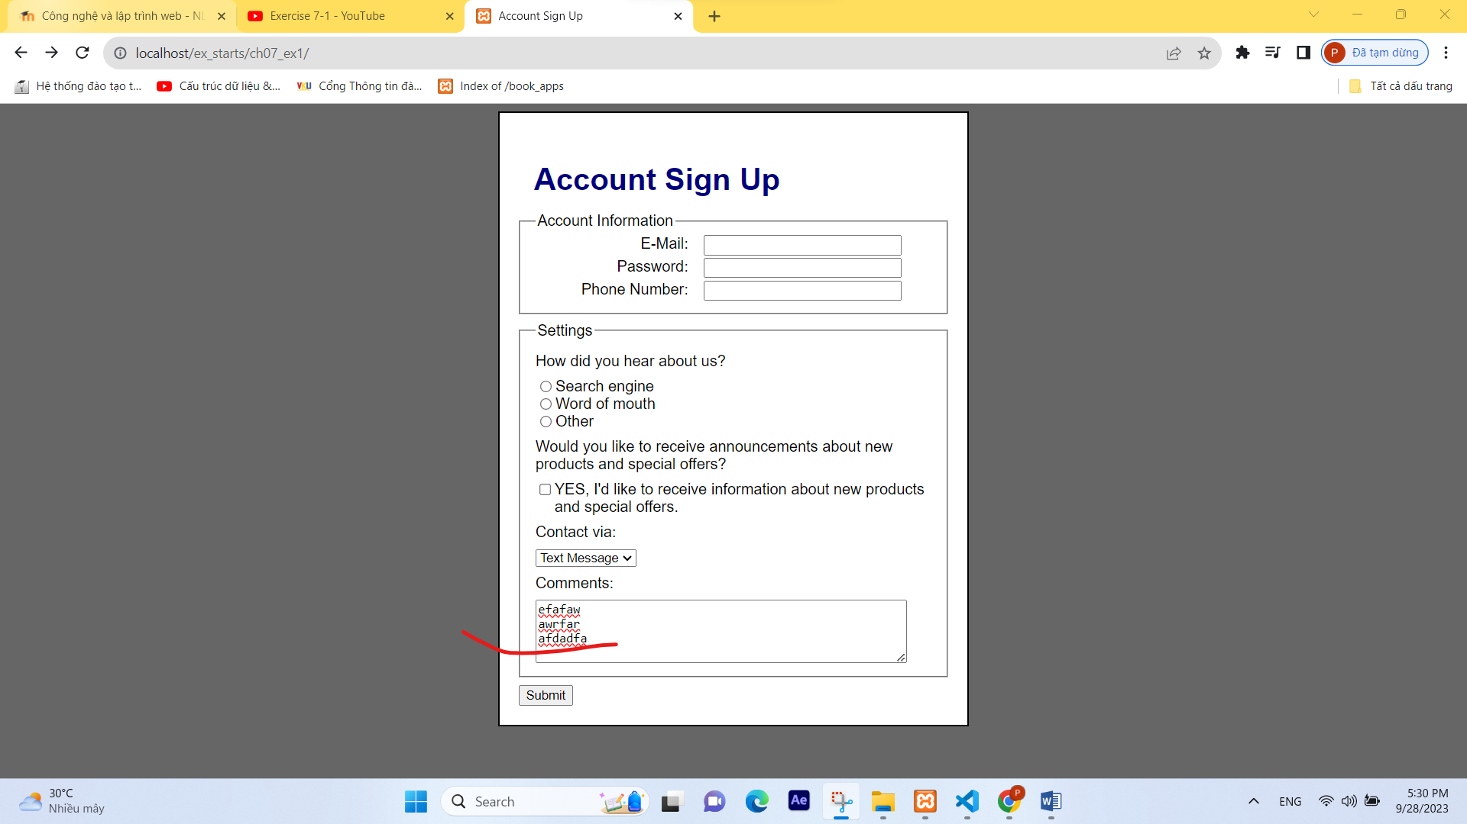

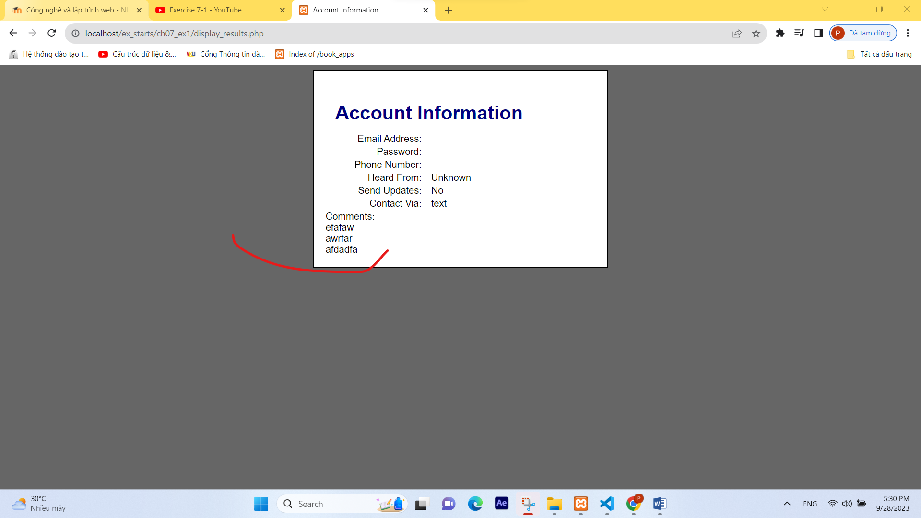

1. Test the application to make sure it works correctly.

